# **Installing UiPath Test Manager Extension in Azure DevOps**

1. Sign in to your organization (https://dev.azure.com/{yourorganization}).
2. Select the shopping bag, and then select **Browse Marketplace**.

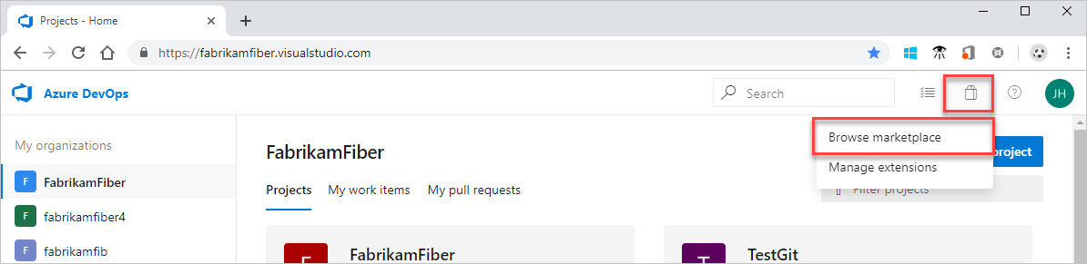

1. Find the UiPath Test Manager extension.



1. Select **Get it free**.
2. Select your organization from the dropdown menu, and then select **Install** to install the extension.

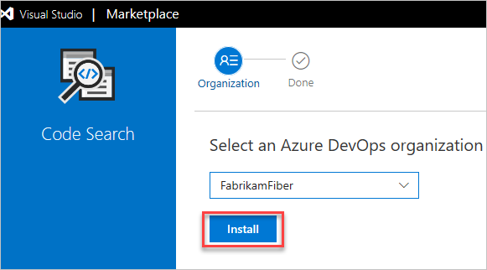

1. Your extension is now installed! You can now go to your organization to use your extension.

# **Integrate Azure DevOps to Test Manager**

Integrate Azure DevOps to Test Manager to support your test management efforts, agile planning, or defect tracking. Through this integration, you can synchronize your work items to Test Manager.

To connect your Test Manager instance to an Azure DevOps project follow these procedures:  
Step 1: Create a Project in Azure DevOps  
Step 2: Configure an Azure DevOps Connection

## **Prerequisites**

* Azure DevOps account.
* Test Manager administrator account
* UiPath Test Manager Azure DevOps Extension

## **Create a Project in Azure DevOps**

1. Log in to Azure DevOps.
2. Click **Create new project** and configure your project settings:
   * **Project name**: Enter a name for your project.
   * **Description**: Add a description to help you easily identify the use of each project.
   * **Version control**: Choose your version control.
   * **Work item process**: Select **Agile** from the dropdown as your default process to support your Agile planning methods, including development and test activities.
3. Click **Create**.  
   Your project is added to your collect

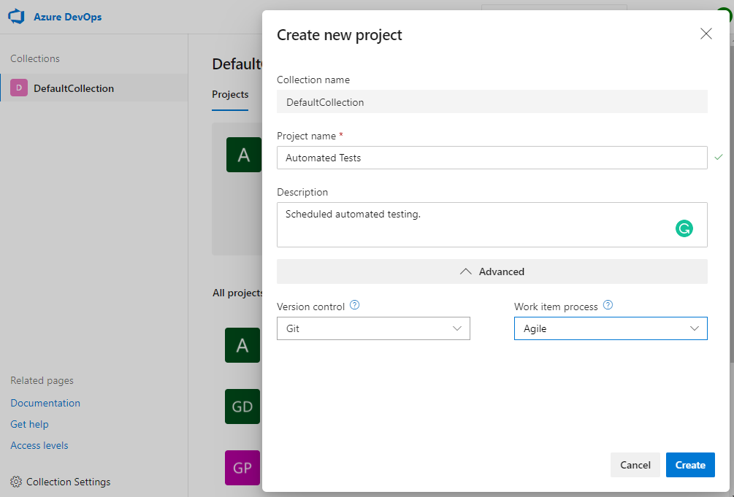

# **Configure an Azure DevOps Connection**

1. Log in to Test Manager as an administrator.
2. Open your project.
3. Navigate to **Project Settings** > **Integration**.
4. Click **New Connection** and select **Azure DevOps** from the dropdown.
5. Configure the following connection settings:
   * **Name**: Enter a name for your Azure DevOps connection.
   * **Description** (Optional): Add a description for reference.
   * **Server URL**: Add the Azure Dev Ops server URL. For example: https://company-name-serverRegion.cloudapp.azure.com.
   * **Personal Access Token**: Create a PAT and paste it into this field to authorize Test Manager to perform actions. For more information, see Use personal access tokens.
   * **Defect Type**: Enter an object type used for bug reporting in Azure DevOps. Otherwise, leave empty if you do not want to use defect integration.  
     Enter a defect type based on what object type you have selected for your newly created Azure DevOps project. For example Bug or Issue.
   * **Project Name**: Enter your Azure DevOps project name.
   * **Click Save**
   * **Copy the API Key generated for the Test Project Integration (*)**

*(UiPath Documentation is misleading)*

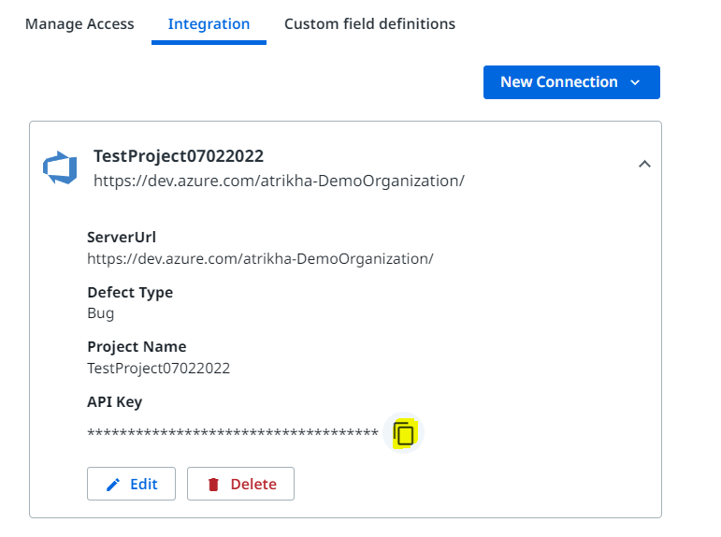

1. Open your project in Azure Dev Ops and go to **Project settings**.
2. Under **Extensions**, go to **UiPath Test Manager**.
3. Configure the following extension settings:
   * **Requirement Types**: Select the types of objects you want to assign a test to. These will show up as requirements in Test Manager. For more information, see Requirements.
   * **Server URL**: Add the Test Manager URL.
   * **API**: Paste the API key. (Generated in Step 5*)
   * **Manage Tests with Azure DevOps**: Select this option to manage your tests through Azure DevOps. Otherwise, leave this option off, to manage your tests through Test Manager.
4. Click **Save**.

